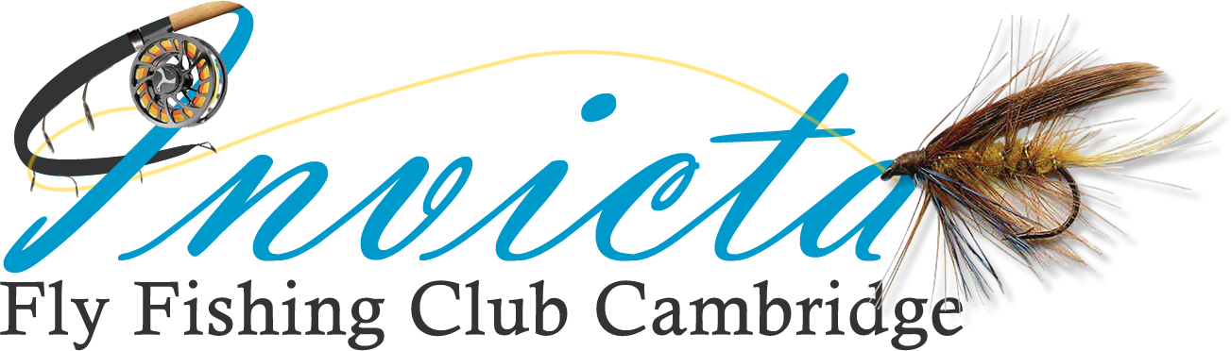
www.invictaffc.org.uk

What to do if you catch a big fish
Two of the Club’s annual Trophies are for the heaviest rainbow (Beecroft Shield) and the heaviest Brown (Brown Trout Trophy) caught by an Invicta member on a day ticket reservoir.
If you catch a fish which you think may be in contention for one of these trophies, please complete the details below and email to Gary How and cc Mark Searle. The fish must be weighed and the weight witnessed by an independent person and should ideally be accompanied by a photograph of the fish being held or placed beside something such as the rod handle and reel to give it scale. Brown Trout must be in season to qualify.

NAME: ………………………………………………………………………….

VENUE …………………………………………………………………………

DATE OF CATCH ………….

Rainbow …… Weight - ………..lbs ……….ozs

Brown ……… Weight - ………..lbs ……….ozs

Witnessed by: ………………………………………………………..

Signed:________________ Date:

Gary How: garyfly@icloud.com
Mark Searle: mark_hse@btopenworld.com

