Review of the season – October 19th 2023
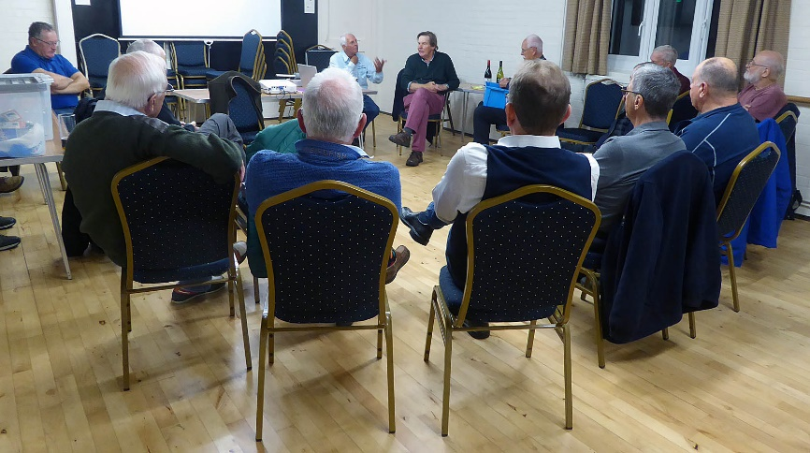
Our initial meeting of the winter programme followed our traditional pattern of a review of the season, compared by David Moore. The first move he made was to organise the audience in a circle which proved to be inspirational in ensuring that all participants could speak to one another across the room. It generated lots of discussions and we even got to know one another better!!

There were lots of topics to consider but I am not sure we delved into them all.
2023 Topics
- Our Club
- How was the fishing
- Water levels and impact
- Participation and Results
- Achievements
- Tackle and tactics what worked and what’s new
- Issues raised, Warm water tactics
- Drogues and how to use them
- Thoughts for next year
Basically, the club has 105 members of which ~40 individual members participated in 14 events organised for club members, including the Carr Cup (won by Tony Smith). Regarding inter-club events, the Tuesday Evening League at Grafham attracted 18/19 anglers every week even though the fishing was, at sometimes, very difficult. Keith Gilchrist won the series with a match to spare! 16 members participated in the Maitland Trophy at Grafham but alas, the team had an off day despite Tony Smith bagging 7 fish. The club runs the Snowbee Floating Line event at Grafham with great success and acclaim. The club entered two teams (from 29 members) in the AFMC series. Team “A” was 2nd in Group 2 and Team “B”, 3rd in Group 3.
Dave Currie has qualified to fish for Team England following an eliminator at the Lake of Monteith.
Paul Heavans, who has developed and successfully run the Club Website for the last 10 years, is standing down and will be replaced by Andy Trafankowski.
Steve Middleton reported on the annual Pilgrimage to Chew Valley. 14 Invicta members participated in this event which has been running 40+ years. Steve reflected sadly on the fact that only a few of the original anglers have survived. He was sure that the event will continue in 2024.
OK, so there have been downsides. The committee sent out a questionnaire to 24 members who had joined in the last 3 years in order to ensure that their needs are met: only 6 responded. There is still time!! Similarly, David Moore expressed disappointment that the there has been a poor response to joining the WhatsApp group. Herewith a description, lifted from the website, showing how to go about joining.
In addition to this website and our Facebook page, Invicta has a member’s only WhatsApp group which you can join by contacting David Moore or Paul Heavens; include your mobile phone number. You will need to have WhatsApp installed on your phone to be able to join the group.
Once you have been accepted you can post to the group such things as requests for boat partners, requests for items of tackle wanted or for sale, details of how venues are fishing etc. The group should not be used for jokes, non fishing or other unhelpful content.
We also endeavour to post last minute information such as if the Grafham Evening Fishing (or other events) are cancelled at short notice due to weather conditions or other unforeseen circumstances.
Remember, if you don’t want lots of pings every time a new item is posted, you can silence notifications on your device. If you require any more information please contact David or Paul.
Things that worked and some that didn’t
- Stroke and stop seemed to out fish pulling hard
- FABS out-fished Blobs
- Fish were usually high: Washing line + 2 FABS
- When to fish dries?
- Yellow Owl CDC popular dry fly everywhere
- Grafham south shore didn’t hold fish all season
- Catching in the heat?
- Snakes, the Inlet and Boils - Marmite

Here is a fuzzy photo from a slide projection of flies used by member, Simon Peck, who along with Tony Smith, won the Carsington Pairs competition earlier in the season.
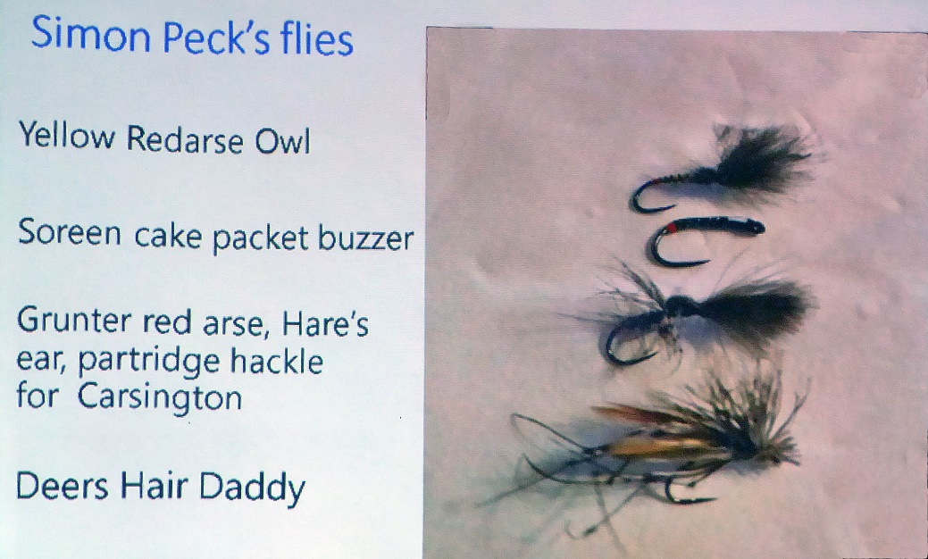

Improved images (although not necessarily exactly the same fly) can be found on the Fulling Mill, Caledonian Flies, and Barry Ord, web sites. Soreen is a malt bread packaged in an orange sheath but I suspect that it has a shiny aluminium film on the inside. The Deer’s Hair Daddy incorporated a detached body of deer hair fibres and not a Muddler style head.

The break enabled us to peruse through the goods presented for sale by members.
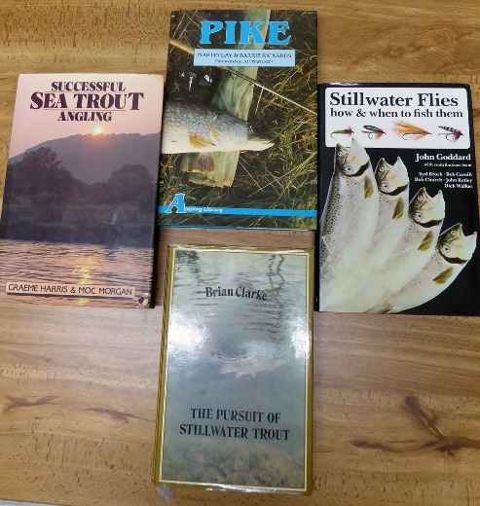
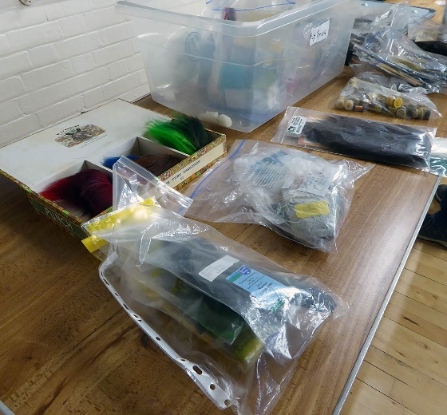

The fly-tying materials attracted a lot of interest and residual items were donated to the fly-tying section of the club. The books, I think, remained unsold. They illustrated the vast improvement in publications over the last 30 years or so with the introduction of improved photography of items such as flies and of course, colour printing.
Finally, we had a presentation from Colin Newton, who runs the fly tying courses, along with Roger Hurren, at Grafham Water.
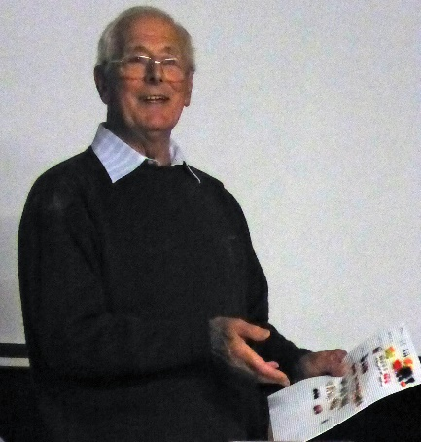

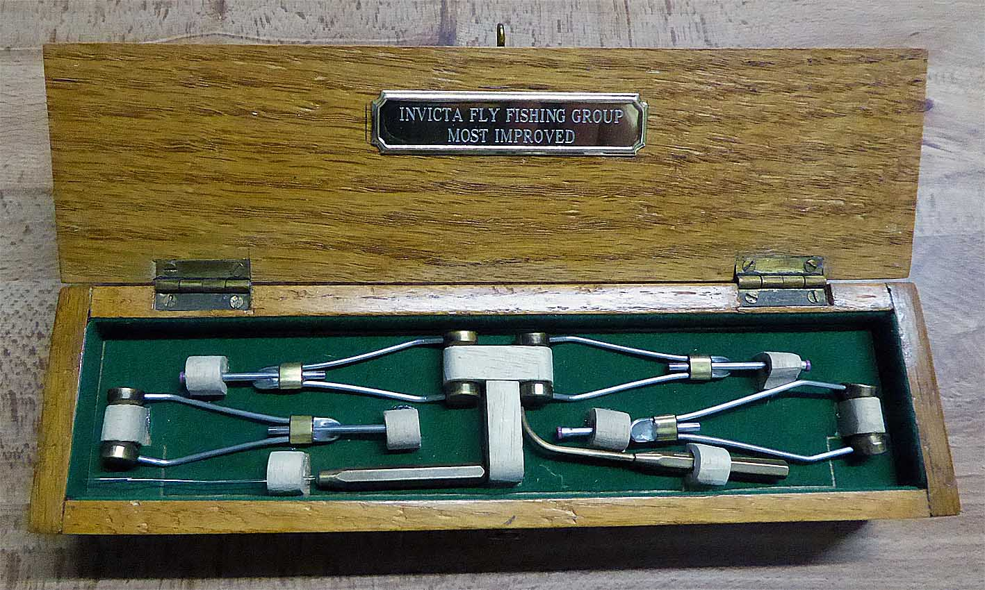
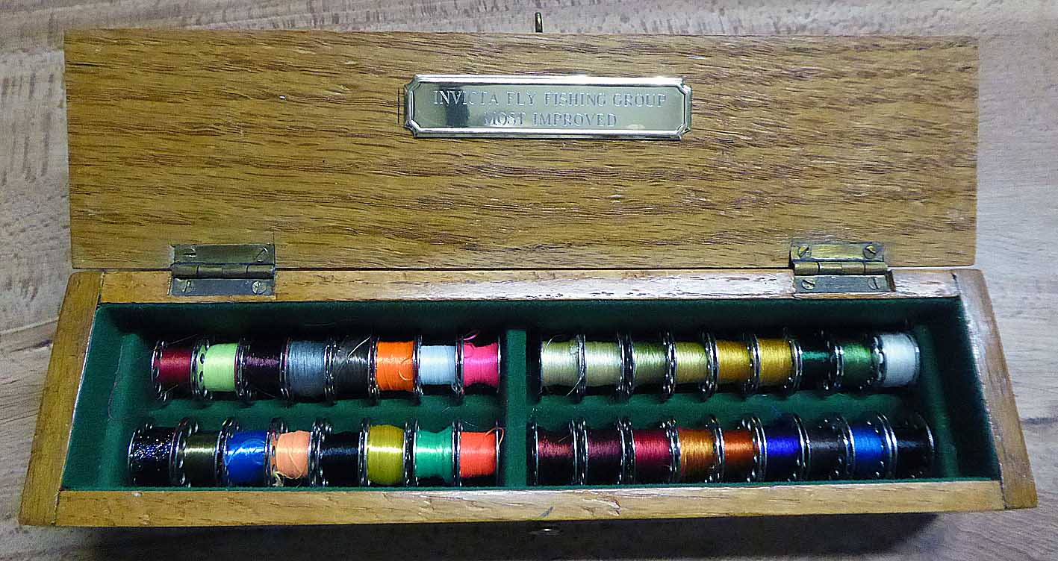

I was most impressed by the strongly structured nature of the course resulting in a progressive advancement in skills. This section of the club, in conjunction with GWFFA, has only been running this season and already there is a rather splendid trophy to be awarded to the tyer showing the greatest improvement over the season. I understand that the trophy was constructed by a participant in the course and modified by Colin to incorporate the spools of silk.
Dave Jones
October 2023

