John Krailing Trophy – Fly Patterns for Experienced 2023/24

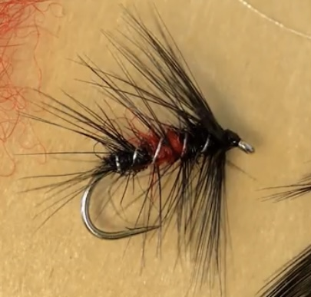
Bibio
Hook Size 10 medium weight wet
Thread Black
Body Tied in 3 equal portions: black/red/black
Seal’s fur or substitute
Hackle Palmered black cock or hen tied down with rib
Rib Medium silver oval tinsel or silver wire

YouTube video How to tie the Bibio – Troutmasters

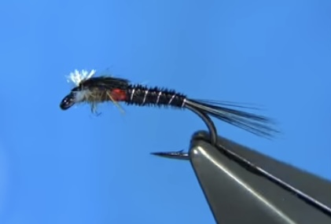
Muskin – Black Midge Pupa
Hook Size 10 heavyweight
Thread Black
Tail Black cock hackle fibres
Body & Thorax cover Black dyed cock pheasant tail fibres
Rib Silver wire
Thorax- rear half Red holographic tinsel
Thorax – front Dubbed hare’s ear
Breathers White yarn, Antron or floss

YouTube video Tying a Muskin’s Black Midge Pupa with Davie McPhail

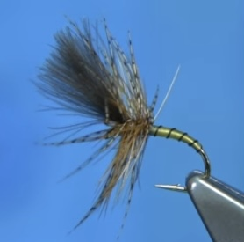
Yellow Owl Grunter
Hook Size 12 medium weight
Thread 8/0 Uni thread colour – Light Cahill
Rib Either fine black wire or black thread
Body Tied tapered with the 8/0 Light Cahill thread
lightly waxed to produce a translucent light olive shade
Hackles Ginger cock tied through a brown partridge hackle to
finish in front of the wing
Wing Natural CDC tied forwards and angled upwards

YouTube video Tying a Yellow Owl Grunter (Dry Fly) with Davie McPhail

