John Krailing Trophy – Fly Patterns for Novices 2023/24

Gold Ribbed Hare’s Ear
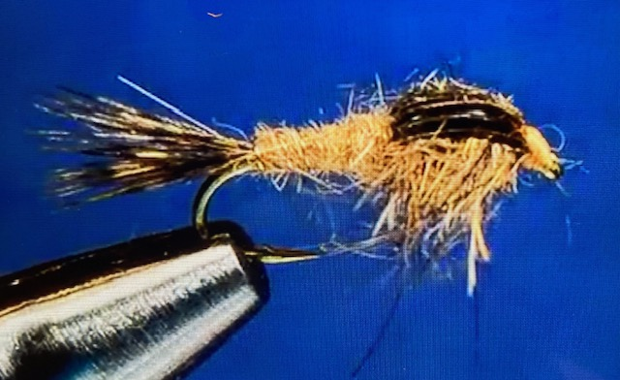
Hook Size 10-12, Kamasan B175 or equivalent
Thread Tan 6/0 or 8/0
Tail Mottled hare’s saddle or cock India saddle fibres
Thorax Hare’s mask dubbing
Abdomen Hare’s mask dubbing
Wing case Turkey feather slip
Rib Small gold wire

YouTube video Gold Ribbed Hare’s Ear Fly Tying – Charlie’s Fly Box

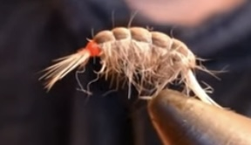
Grafham Killer Shrimp
Hook Size 10-12, Kamasan B100 or equivalent
Weight Lead foil/wire
Rib 3lb mono
Body Tan Sowscud dubbing and sandy hare’s fur 50:50
Shellback Tan Wapsi Thinskin
Hot spot Red

YouTube video Tying the Grafham Killer Shrimp fly - Tim Joyce Flyfishing-Essex

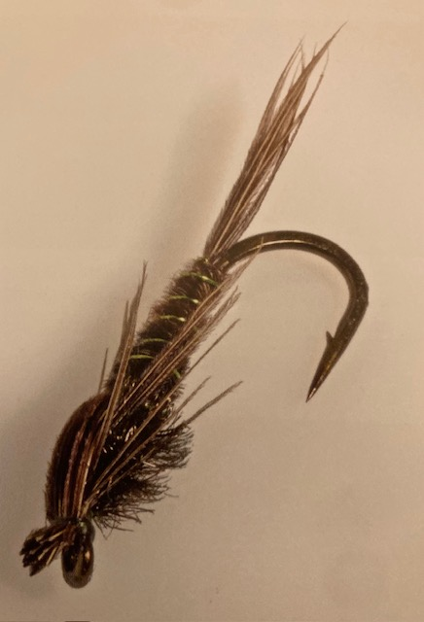

Pheasant Tail Nymph
Hook Size 8, Kamasan B175 or equivalent
Thread Olive
Tail Cock pheasant tail fibres
Abdomen Cock pheasant tail fibres
Rib Fine or medium copper wire
Thorax Peacock herl
Wing case Cock pheasant tail fibres
Legs Cock pheasant tail fibres

YouTube video Tying the Pheasant Tail Nymph with Barry Ord Clarke

